My own review 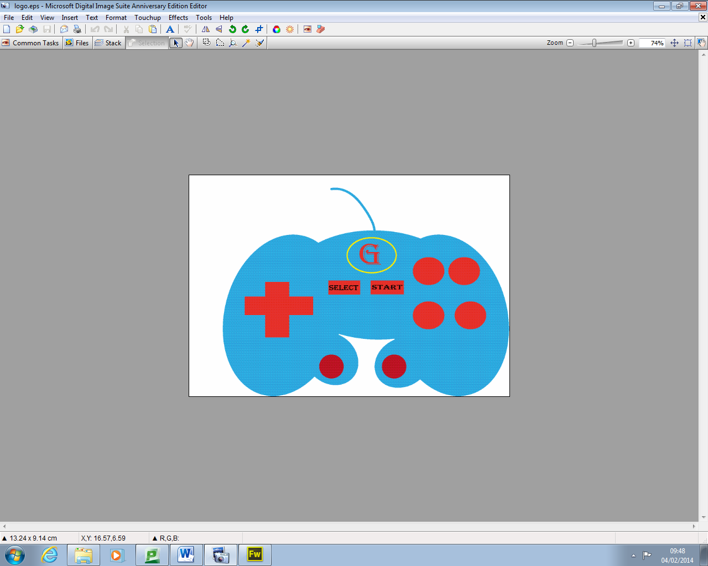

Logo

The logo I have created meets the user requirements because it’s relevant to gaming and the logo tries to replicate an Xbox controller and I have used the user requirements that I got sent through like 300 PPI and the page is set to A4 Landscape and I have used a maximum of 3/4 colours like for example

* Blue
* Red
* Yellow

All there codes are on the design documents

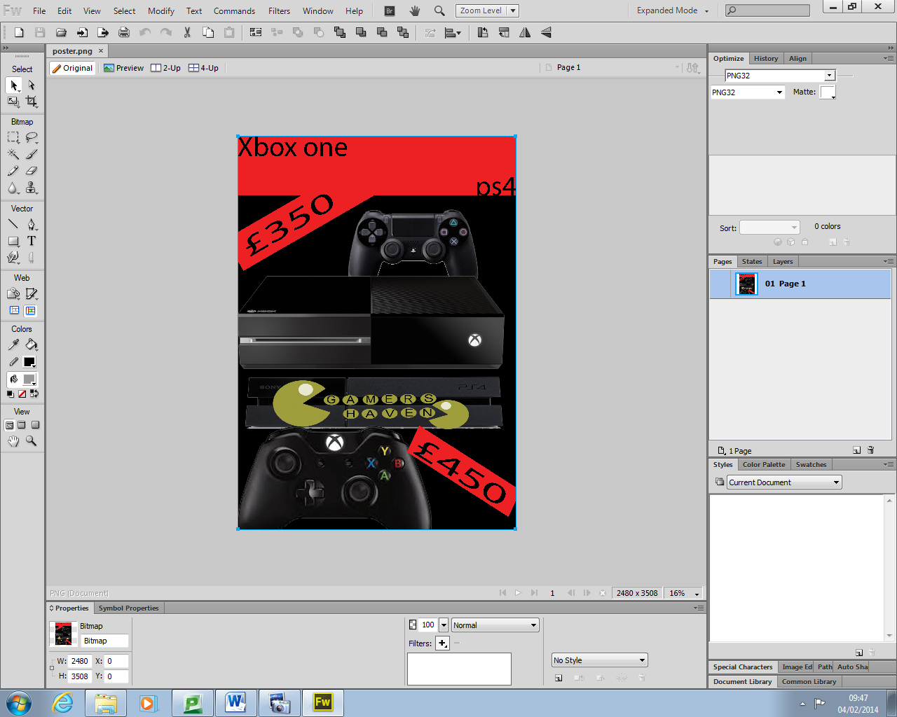

The poster;

The poster I have created meets the user requirements because the requirements of the customer was to set the page in A4 and use two colours and all the assests have being edited through Photoshop before putting them into my poster they could be some changes made to the poster the colours that I have used are

* Black
* Red
* And the colours on the assests

The assests are listed in the assets table document and the codes are on the design document I made 1 mistake then I changed it the mistake is stated in the design documents